**Data Science**

**Product Revenue prediction**

I will apply [regression learning](http://www.tatvic.com/blog/linear-regression-using-r/) on product transactional data for defining most effective variables that can impact on product transactional revenue

**Applying Regression model in R**

I have collected list of necessary variables from available Google analytics dataset for predictive model development, which are  
  
Response/dependent variable:

1. yitemrevenue – Item Revenue at Rs

Explanatory/independent variables:

1. xcartadd – Numbers of instance added to cart
2. xcartuniqadd – Numbers of unique instance added to cart
3. xcartaddtotalrs –Total Rs after instances added to cart
4. xcartremove- Numbers of instances removed from cart
5. xcardtremovetotal – Total numbers of instances removed from cart
6. xcardtremovetotalrs – Total  Rs after numbers of instances removed from cart
7. xproductviews – Numbers of page views
8. xuniqprodview – Numbers of uniqe product views
9. xprodviewinrs – Rs at total numbers of page view

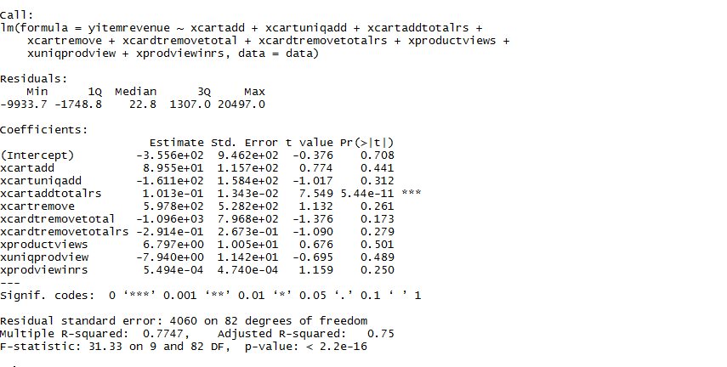

With reference to this model summary, we have Residual standard error as 4060, which should be as small as possible (logically with value 0 denotes perfect prediction). Where Multiple R squared as 0.7747 which denotes this model has nearly 77% prediction accuracy. We can see that xproductviews have more impact on the product revenue. Here, 6.797 unit increase in product revenue explained by 1 unit increment in xproductviews.

**Results with changes in the data**

I have made a dummy data of 25 records in which i have increased the Item Revenue of 5 products and in those 5 records I have also increase 3 values of Product Views, following are the results of my model

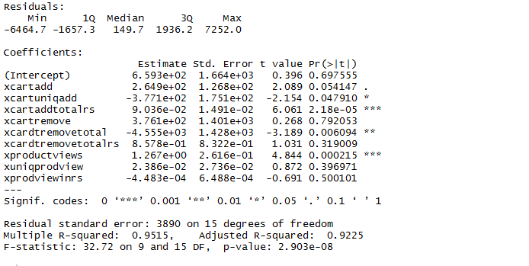

With reference to this model summary, we have Residual standard error as 3980, which should be as small as possible (logically with value 0 denotes perfect prediction). Where Multiple R squared as 0.9515 which denotes this model has nearly 95% prediction accuracy. We can see that xcartaddtotalrs have more impact on the product revenue. Here, 9.036 unit increase in product revenue explained by 1 unit increment in xcartaddtotalrs.